**CIS4560 Term Project Tutorial**

**Authors: Jonas Sanchez, Nicholas Lee, Ricardo Vergara, Nickolas Elkin, Aaditya Kandel,**

**Instructor:** [**Jongwook Woo**](https://www.linkedin.com/in/jongwook-woo-7081a85)

**Date: 11/22/2024**

**Lab Tutorial**

**Jonas Sanchez (**[**jsanc479@calstatela.edu**](mailto:jsanc479@calstatela.edu)**) Ricardo Vergara (**[**rvergar@calstatela.edu**](mailto:rvergar@calstatela.edu)**) Nicholas Lee (**[**nlee65@calstatela.edu**](mailto:nlee65@calstatela.edu)**)**

**Car Accident Analysis using Big Data**

**Objectives**

**In this hands-on lab, you will learn how to:**

* **Use LFS to upload Big data Sets to Github**
* **Import Data into a Hadoop Cluster**
* **Parse the Necessary Data into another Table**
* **SQL commands to perform the analysis.**
* **Visualization**

**Step 1: Use LFS to Store Large Amounts of Data into a GitHub Repository**

**Git hub is a useful repository for developers to store, create, and work together on various projects. One Limitation that this service has is the file size restrictions. Only files less than 25MB can be hosted in a repository.  Well, what if you have files that exceed this limit? You will have to use LFS(Large File System) to store the data locally, but can still be accessed via the repository for users to access.**

1. **Download LFS and Git for your OS system**

**2.       Open a git shell and perform the following commands where “” is for you to fill out with your filename extension.**

**git lfs track "*.csv"      ##Tracks the filename**

**git add file.psd           ##Adds the file to the repository**

**git commit                 ##Commits to the repo**

**git push origin main       ##Pushes changes to the repo**

**3.       Check your repo and ensure you see the file with an LFS tag**

**Example:**

**4.       Now you can download the file from the repository. Ensure that the device hosting the source file is accessible and has access to the repository.**

**Step 2: Import Data into the Hadoop Cluster**

**Now that we are able to push and pull large datasets from the repo, we can pull the file into our Oracle Linux Server to and parse the data using the Hadoop Cluster :**

**1.Use wget to pull from the github repository and place the files in the directory of your Hadoop cluster user**

**wget https://github.com/CIS-4560/US-Accidents-2016---2023-/raw/refs/heads/main/US_Accidents_March23.zip**

**unzip US_Accidents_March23.zip**

**hdfs dfs -mkdir tmp/US-Accidents_02_16-03_23**

**hdfs dfs -mkdir tmp/new_US-Accidents_02_16-03_23**

**hdfs dfs -put US_Accidents_March23.csv tmp/US-Accidents_02_16-03_23/**

**2. Using Beeline, create a table for the imported data set. Because the file is a CSV format, we need to use “,” as a delimiter.**

**CREATE EXTERNAL TABLE IF NOT EXISTS US_Car_Accidents (**

**ID string,**

**Source string,**

**Severity INT,**

**Start_time TIMESTAMP,**

**End_time TIMESTAMP,**

**Start_Lat string,**

**Start_Long string,**

**End_Lat string,**

**End_Long string,**

**Distance_miles float,**

**Description string,**

**Street string,**

**City string,**

**County string,**

**State string)**

**ROW FORMAT DELIMITED**

**FIELDS TERMINATED BY ","**

**STORED AS TEXTFILE**

**LOCATION "/user/jsanc479/tmp/US-Accidents_02_16-03_23/"**

**TBLPROPERTIES ('skip.header.line.count' = '1');**

**3. Because we want to filter for unwanted data in this dataset, we need to create a separate table that only includes the information we will be using in our data analysis. The new table will be removing End_Lat, End_Long,Source, Description, Street, and County. We will also be reducing the max time for the new dataset. We will filter for accidents that occurred in and after 2022.**

**DROP TABLE IF EXISTS new_US_Car_Accidents;**

**CREATE TABLE new_US_Car_Accidents**

**ROW FORMAT DELIMITED**

**FIELDS TERMINATED BY ','**

**STORED AS TEXTFILE**

**LOCATION "/user/jsanc479/tmp/new_US-Accidents_02_16-03_23/"**

**AS**

**SELECT ID, Severity, Start_time, End_time, Start_Lat, Start_Long, Distance_miles, City, State**

**FROM US_Car_Accidents**

**WHERE Start_time > '2021-12-31 23:59:59'**

**ORDER BY Start_time DESC;**

**4. Once this new table is created, we can go ahead and copy this new dataset from the Oracle Linux Server onto our host machines, where we will be performing Data Analysis.**

**#Copy new table to linux machine#**

**hdfs dfs -get /user/*YOUR_USERNAME*/tmp/new_US-Accidents_02_16-03_23/000000_0**

**cat 000000_0 > US-Car-Accidents_02_16-03_23.txt**

**#Copy new table to local machine for Data Analysis#**

**scp*YOUR_USERNAME*@129.146.230.230:/home/*YOUR_USERNAME*/US-Car-Accidents_02_16-03_23.txt**

**Step 3: Convert from txt file to xlsx**

**1.Open  Excel on your local computer. Import the text file and click delimited**

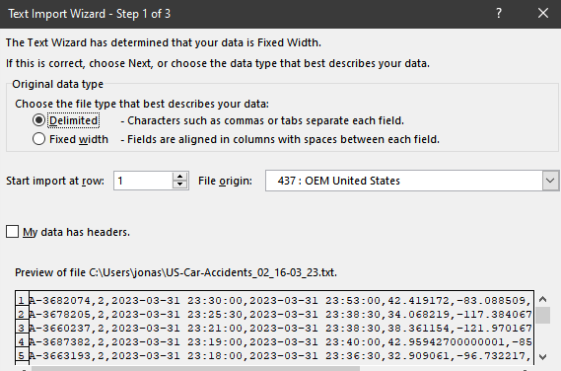

1. **Check comma as the delimiter**

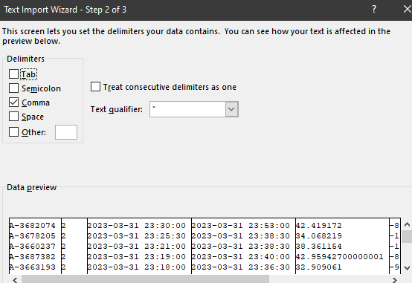

1. **Create the proper headings for each column (record, severity, date start, date end, latitude, longitude, distance, city, and state from left to right). You may cull any of the 2023 entries to make space for the headings.**

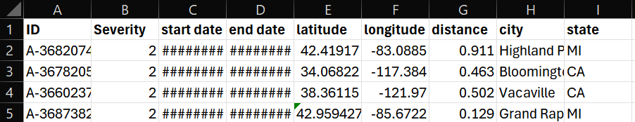

1. **Save the file as an .xlsx to use Excel Power Maps**

**Step 4: Analyze the data using various Data Analysis Tools**

**Excel Power Maps**



**Using Excel Power Maps, we can generate and visualize data over a period of time. This helps determine trends using the data we downloaded and analyze it both geographically and temporally. The visual above shows the number of crashes and their severity by time and city over the course of two months across the nation. As seen in the visual, the number tends to fluctuate throughout the timeframe.**

1. **Open the .xlsx file you imported into Excel from the previous section.**
   1. **If the data is not in a table format (with headings for each column) make sure to adjust your data so it is formatted into a table.**
   2. **You must also make sure that the 3D Maps Add-In is installed and enabled on your excel sheet. (newer versions of Excel do not need this step and in those versions 3D maps can be accessed via the top search bar above ‘Help’)**
2. **Once you have your data, navigate to the ‘Insert’ section above the tool ribbon and then click ‘3D Maps’ on the tool ribbon. Open up a new tour to open the 3D map. (Alternatively, on newer Excel versions you may search ‘3D Map’ in the search bar above the tool ribbon to open a new tour)**

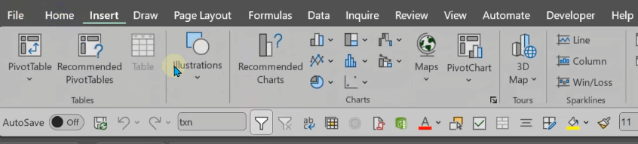

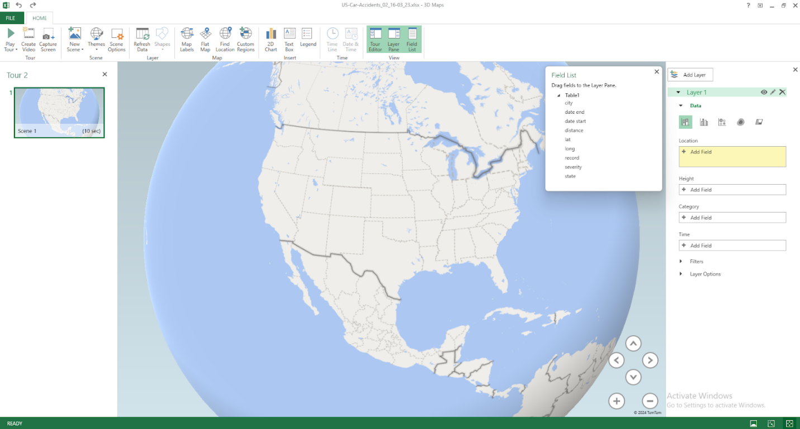

1. **To populate the map, drag the city field into location. Once you have done that, make sure the drop down menu to the left of the field is set to the right field.**

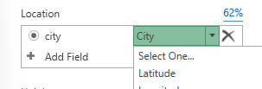

1. **To filter all results in the US, drag the state field into the Location box and select State/Province from the drop down menu. Make sure the circle to the right of city is still marked black.**
2. **Drag Severity into the Height box under Location. Make sure it is set to ‘Sum’ in the drop down menu.**
3. **Drag the Severity field into the Category box**
4. **Drag the Date Start field into Time box**

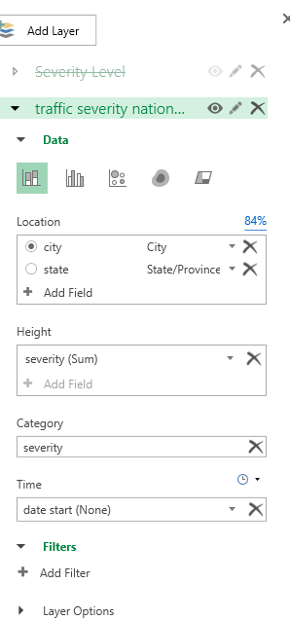

1. **Once that is done, click the gear icon on the bottom left of the playback bar located on the bottom of the screen to set the timeframe.**

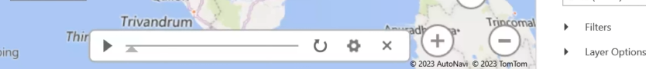

1. **Make sure the start date is 7/9/2022 at 7:00:00 AM and the end date is 9/8/2022 at 11:59:59 PM. Change both accordingly.**
2. **Change the speed bar to your liking.**

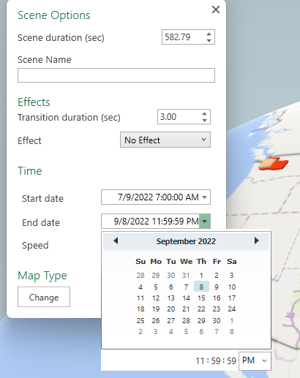

1. **On the left side tab, under the Time box there are two tabs: Filters and Layer Options. Click on the Layer Options tab and adjust the height, thickness and colors of the bars to your liking.**

**Tableau**

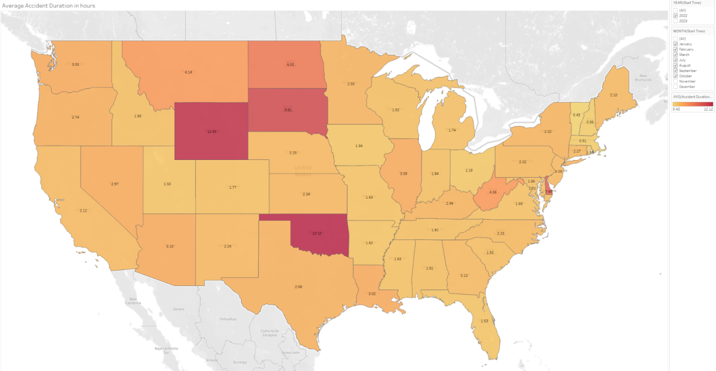

**Average Accident time in US January-October 2022**

**Using tableau, you are able to use Geo-Mapping features to your data to get a visual picture of what your data means. In this chart, we can see the Average Accident time reflected by the different States in the US. OK (Oklahoma) shows as the highest Avg time for an accident to clear from the point of impact, to when traffic is no longer affected. We are able to see that the highest times are reflected more in rural areas rather than cities. We can assume this may be due to the large amounts of area without a heavy population. This can cause accidents to take longer to resolve, because the authorities who need to assist with clearing the roads, may not be as close as in heavily populated areas.**

1. **Import your data into Tableau**
2. **There should be 9 columns for this dataset. Fill in the Headers with the correct Column names. In our case, you should fill each column with the following names:**
   1. **ID, Severity, Start_time, End_time, Start_Lat, Start_Long, Distance_miles, City, State**

**Example:**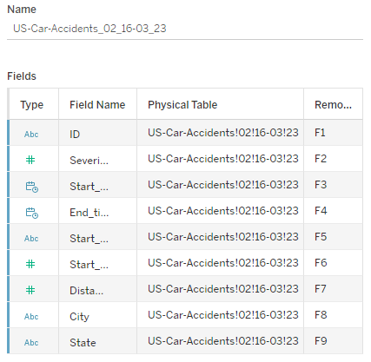

1. **Open sheet 1 with the new labeled datasets. We need to change the data types for Latitude and Longitude so Tableau can recognize these numbers.**
   1. **Right click on Lat/Long and set the geographic role to either Lat/Long depending on which you are working on**
      1. **Note: If the correct geographic role does not show up, ensure the data type is set to decimal number, not string.**
   2. **We also need to ensure the correct geographic role for States is set as well. Set the the geographic role for states to States/Province**

**Note: Now that we have all of our geographic data, we can work on what we want our Map to show. Because we are trying to find the Average time for crashes to clear,we need a function to tellus this information**

1. **Create a Calculated Field:**
   1. **Go to the Data Pane, right-click, and select Create Calculated Field**
   2. **Name it “Accident Duration (hour)”**
2. **Use the following formula:**
   1. **DATEDIFF('hour', [Start_time], [End_time])**
   2. 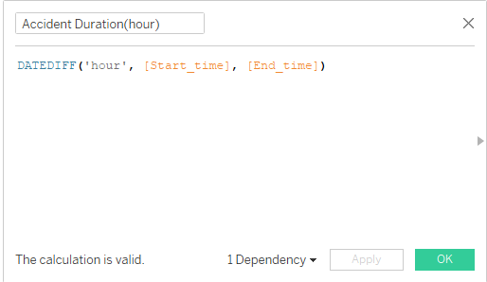

***Note: This formula calculates the difference between start_time and end_time in hours***

1. **Now that we have all the necessary data types and averages, we can create out Map. Start by dragging “State” to the Marks box from the left pane.** 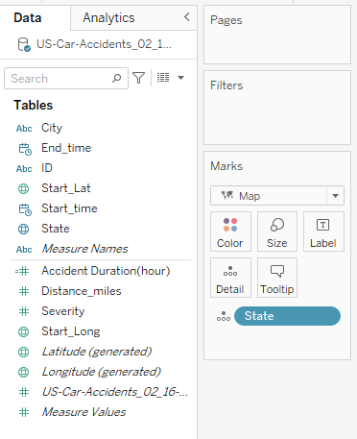
2. **On the upper right in tableau, click the ‘Show Me’ icon and select ‘Maps’ to create a map visualization**

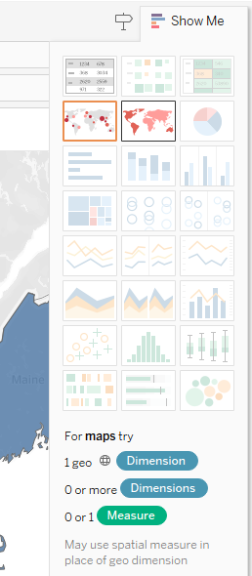

1. **Now that we have our map, we need to find the average time of the car accidents cleared by state. Using the function we created, we can filter thai for every state. Drag the newly made function “Accident Duration (hour)” into the marks box over colors**
   1. **Ensure the measure is set to Average and not Sum**
   2. **Change the color scheme to Red-Gold**
   3. **In the Marks pane, ensure Label box is checked to display values**

**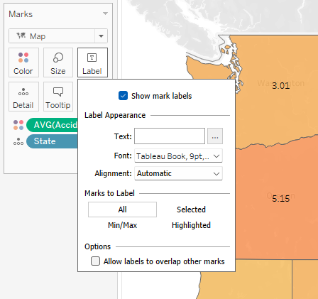*.***

**References**

**1.       URL of Data Source, https://www.kaggle.com/datasets/sobhanmoosavi/us-accidents/data**

**2.       URL of your Github**

**https://github.com/CIS-4560/US-Accidents-2016---2023-**

**3.       URL of References**

***THIS IS THE END OF THE TUTORIAL***